## Final Project Write Up

## Ian Arch, Paige Breyfogle, Daniel Buescher & Andrew Stepanek

For the final project, we will be expanding on a previous project’s dataset with the 151 original Pokemon and their stats.

We are going to use machine learning to create an algorithm or a program to predict the outcome of a fight based on the stats we have gathered previously and taking an algorithm into account to assign weighted values to the different stats.

We will deploy our ML algorithm on an HTML page, with two active drop downs to select the different Pokemon for the fight, and then a “Fight” button to initiate the machine learning app. We will have a pair from the group tackle the creation and deployment of our ML algorithm, while the other pair will be more focused on the design of the page as well as putting the presentation together. There will obviously be some cross over between the two groups but that is how we have it broken out right now. I think we will utilize TensorFlow for the machine learning algorithm, but we are not completely sure. As far as the web page we will use css and javascript libraries to make it pretty, we will use a python- flask app to pull data that is stored in a postgres database.

Roles:

Ian – Code Transformation: Manipulating last project’s code to work with our new project’s direction.

Andrew – Machine Learning: Developing machine learning algorithm for fight predictions.

Paige– Web Design: Utilizing HTML, CSS and JavaScript to create a visually appealing and functional page layout.

Daniel – Testing & Presentation: Testing functionality of code and pulling together presentation

This is a set-up that we are drawing a little inspiration from, we want to show a Pokemon preview before the battle once the Pokemon are selected, similar to this battle simulator I found online.

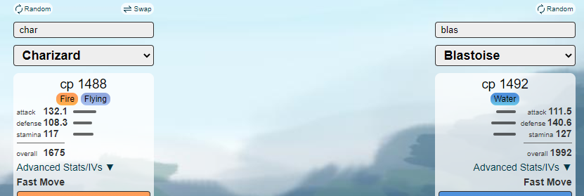

In a perfect world we will have the photos and a brief breakdown of the stats of each Pokemon before the battle is launched.